PL-SQL LAB1
NAME: NALLAPANENI VAIBHAV
ROLL NO: AM.SC.U4AIE23135
QUESTION 1:
- ODD OR EVEN:
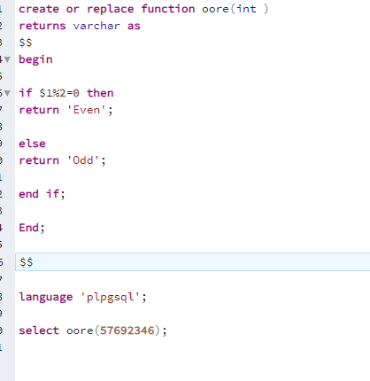
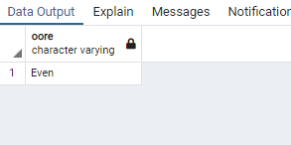

- SUM:
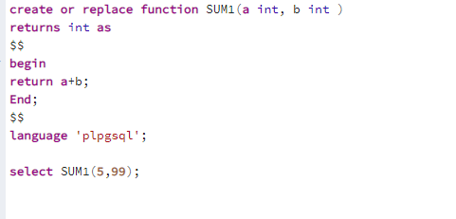

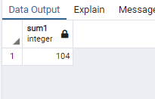

- Emp_salary:
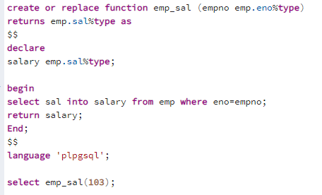
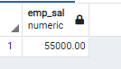

- Number of Employees:
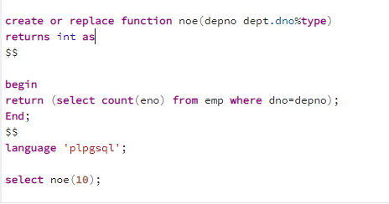
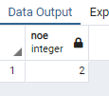
- Salary hike:
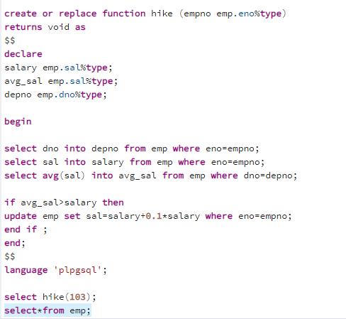
- Dep_name
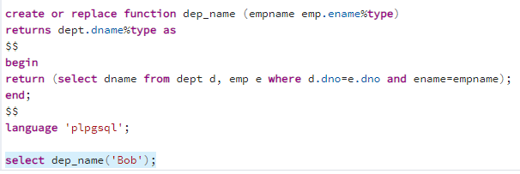
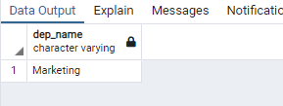

QUESTION_2:

- Total numbers worked on all projects
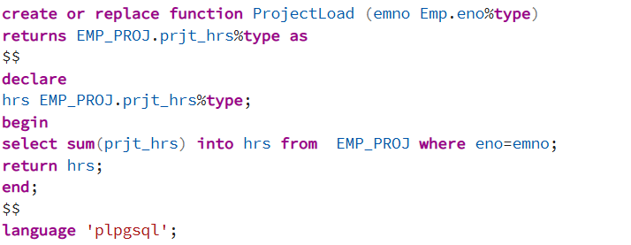

OUTPUT:

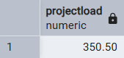

- Update sal is sal < avg(sal)
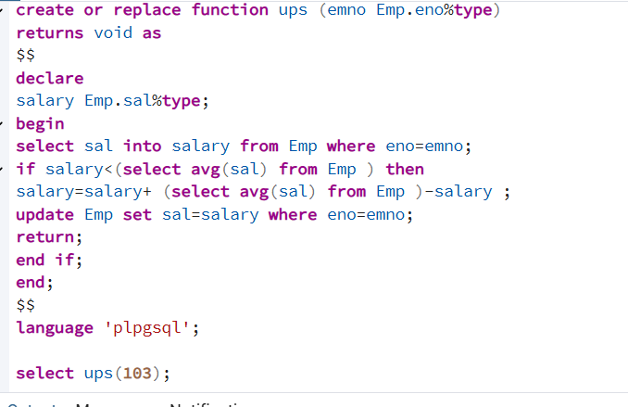

OUTPUT:
Question-3:
Consider the following tables Item(ino, iname, unit_price) Transaction(tr_no,ino,qty) Write a function to accept an item no from the user. If transaction has been made for less than 2 times for that item(check from transaction table), delete the item from the Item table.
Answer:
CREATE OR REPLACE FUNCTION delete_item_if_few_transactions(p_ino INTEGER)
RETURNS VOID AS $$
DECLARE
transaction_count INTEGER;
BEGIN
-- Count the number of transactions for the given item
SELECT COUNT(*) INTO transaction_count
FROM Transaction
WHERE ino = p_ino;

-- If fewer than 2 transactions, delete the item
IF transaction_count < 2 THEN
DELETE FROM Item
WHERE ino = p_ino;

RAISE NOTICE 'Item % deleted due to insufficient transactions (%).', p_ino, transaction_count;
ELSE
RAISE NOTICE 'Item % retained. Transactions: %.', p_ino, transaction_count;
END IF;
END;
$$ LANGUAGE plpgsql;

SELECT delete_item_if_few_transactions(103);

QUSTION 4:

create or replace function update_customer_type(threshold numeric, cust integer)
returns void as $$
declare
total_bal numeric;
new_type char(1);
begin
select sum(bal) into total_bal from accounts where cust_no = cust;

if total_bal is null then
raise notice 'customer has no accounts';
return;
end if;

if total_bal > threshold then
new_type := 'a';
else
new_type := 'b';
end if;

update customer set c_type = new_type where cno = cust;
end;
$$ language plpgsql;

create or replace function closebranch(old_branch integer, new_branch integer)
returns void as $$
begin
update accounts set br_no = new_branch where br_no = old_branch;

delete from branches where br_no = old_branch;

raise notice 'branch % closed', old_branch;
end;
$$ language plpgsql;

create or replace function safe_withdraw(ac integer, amount numeric)
returns text as $$
declare
current_bal numeric;
begin
select bal into current_bal from accounts where ac_no = ac;

if current_bal is null then
return 'account not found';
end if;

if current_bal < amount then
return 'insufficient funds';
end if;

update accounts set bal = bal - amount where ac_no = ac;

return 'withdrawal successful';
end;
$$ language plpgsql;

select safe_withdraw(1001,200);

